Task on ASG

- Create one VPC in N. Virginia region.

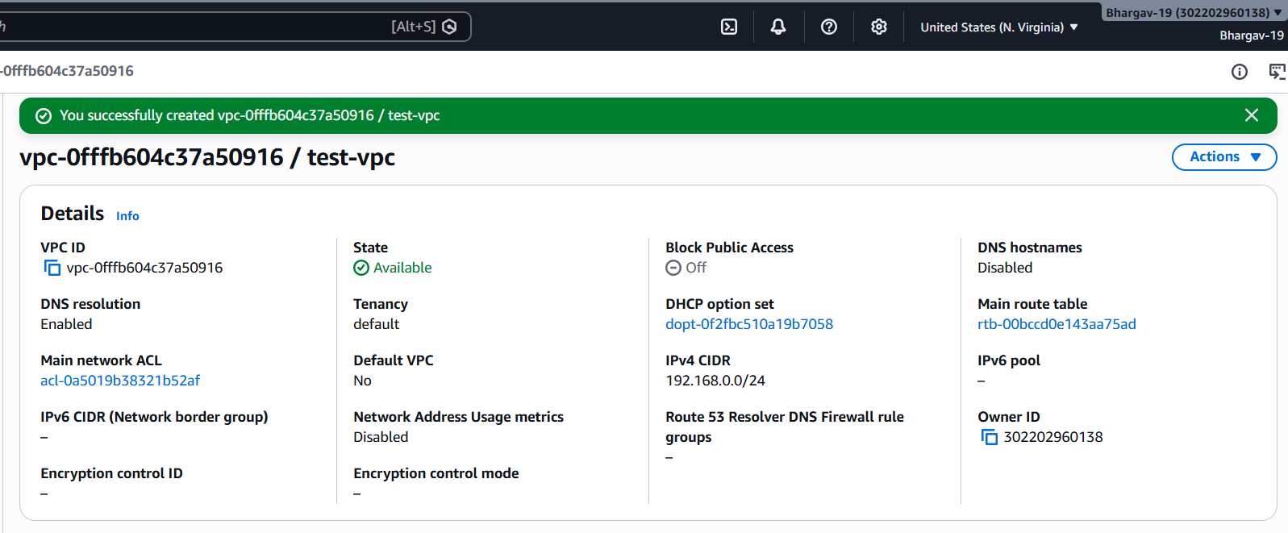
- Create two subnets: one public subnet and one private subnet.
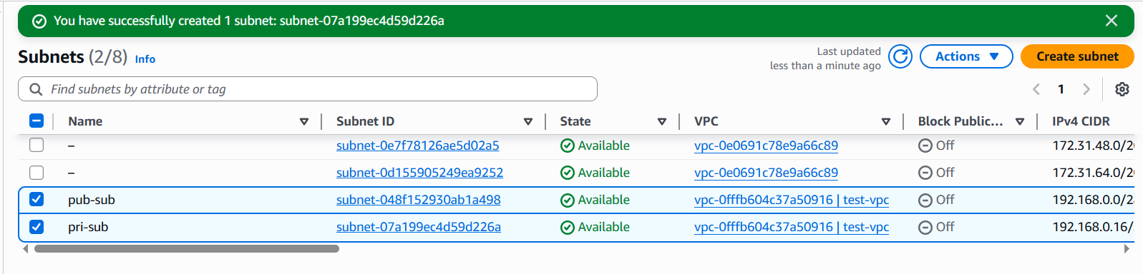
- Attach an IGW to the VPC.
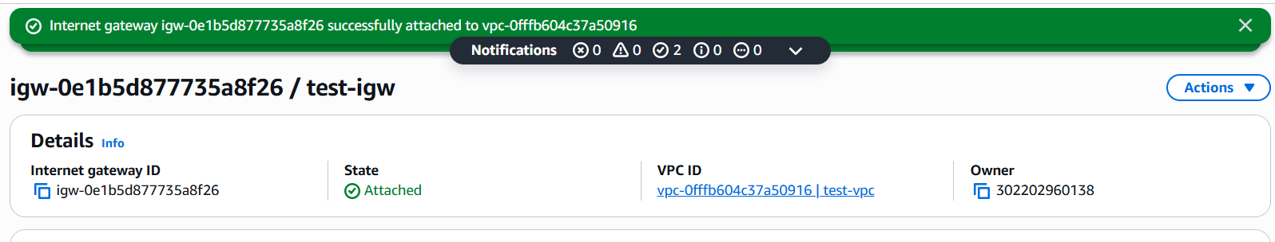

- Create one public route table (RT) and one private route table.
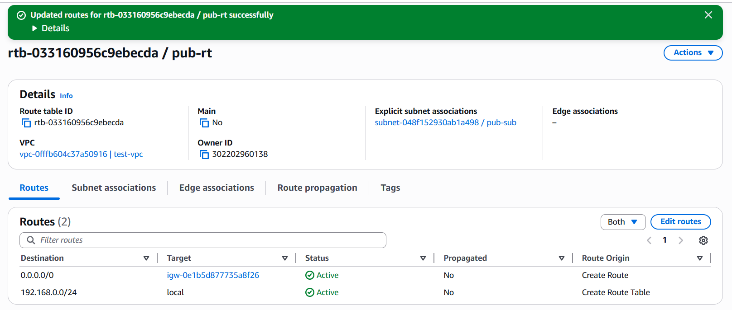

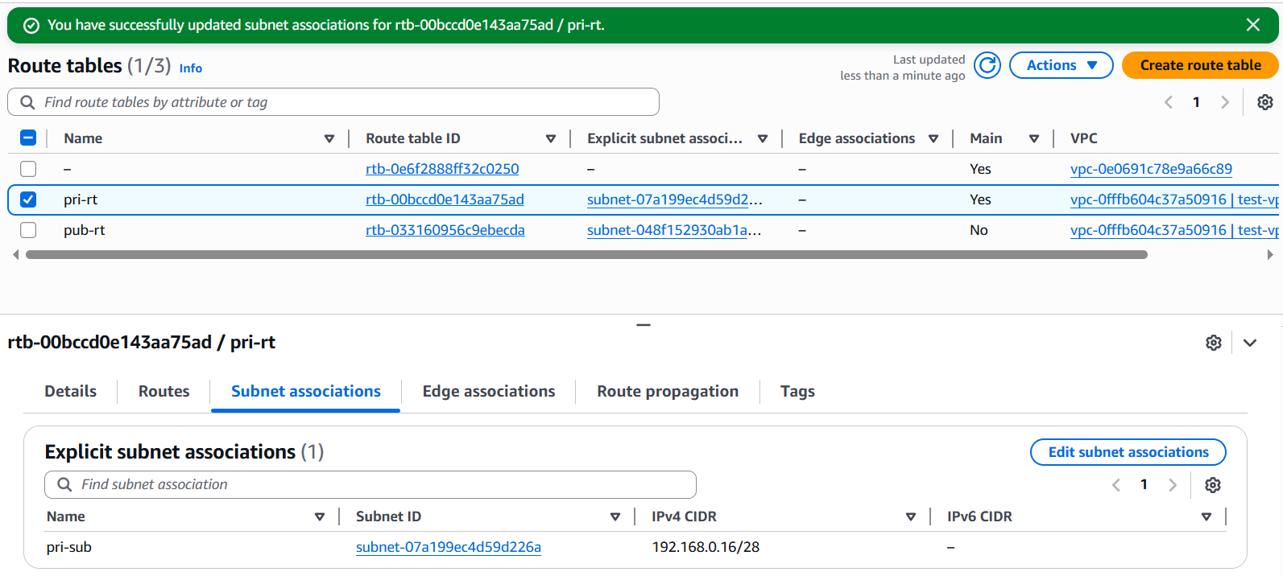
- Deploy a NAT gateway in the public subnet and attach the NAT gateway to the private subnet.
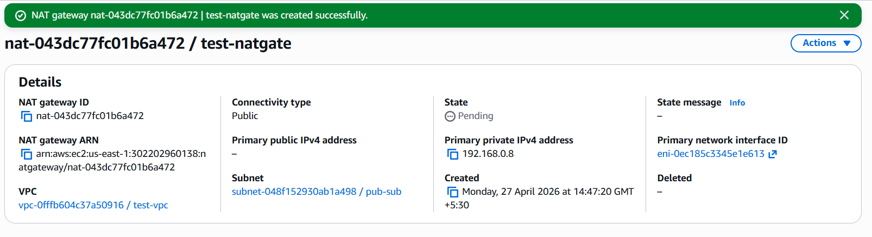

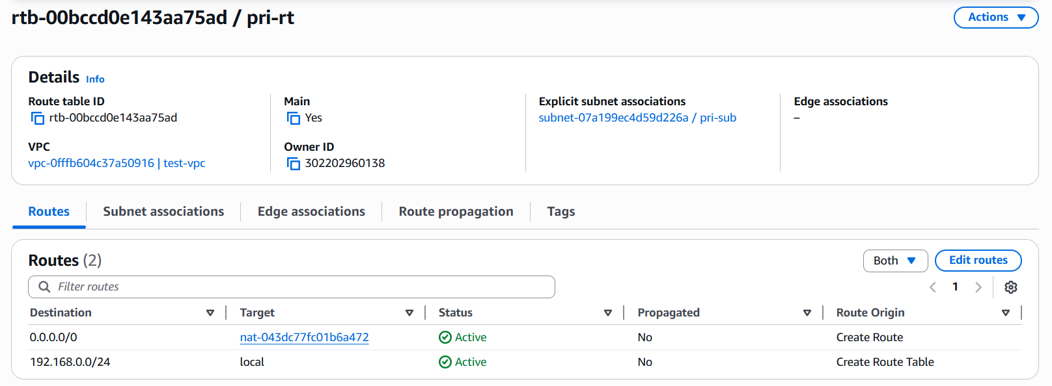

- Create two instances, one in the public subnet and one in the private subnet.

Create an instance in subnet
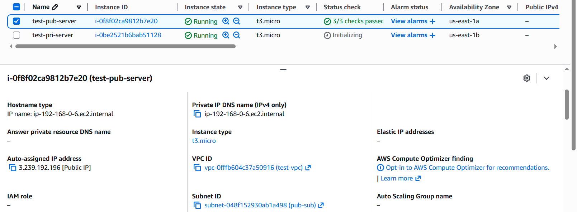

Create an instance in private subnet

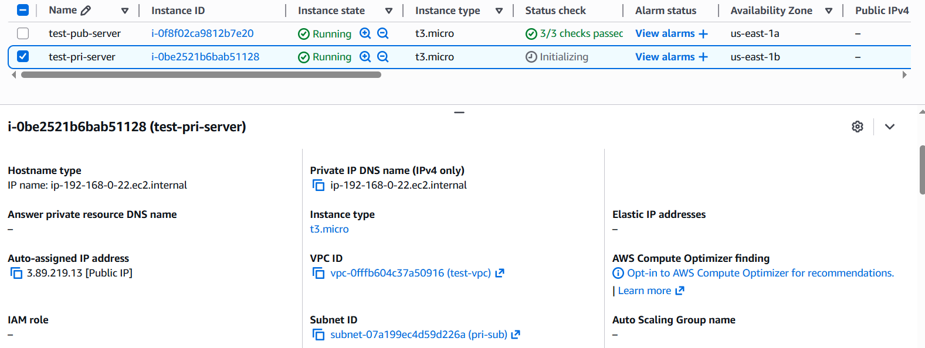

- Deploy Apache server on both EC2 instances with a sample index.html file.

Ssh to pubic server and install apache and start the service
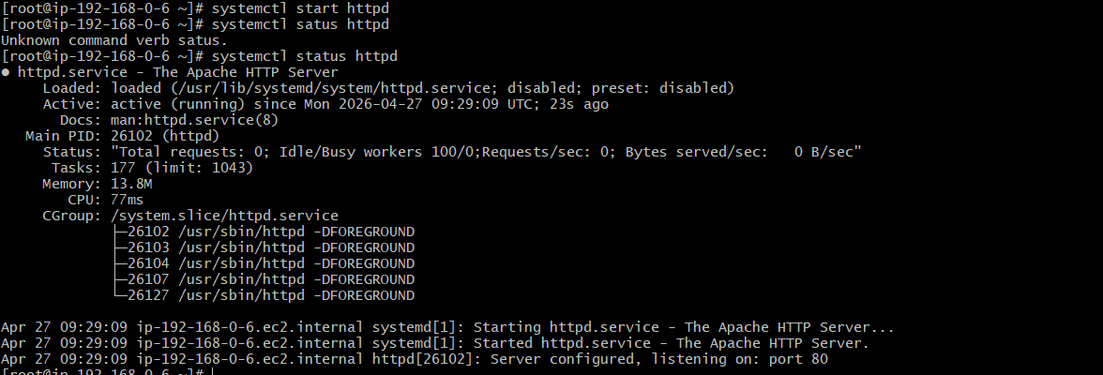

Deploy content in index.html file


Check in the browser by using public Ip
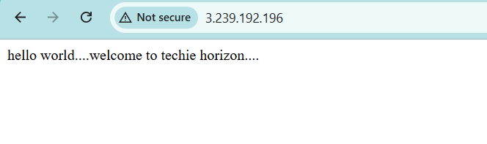
Ssh to the private server through public server
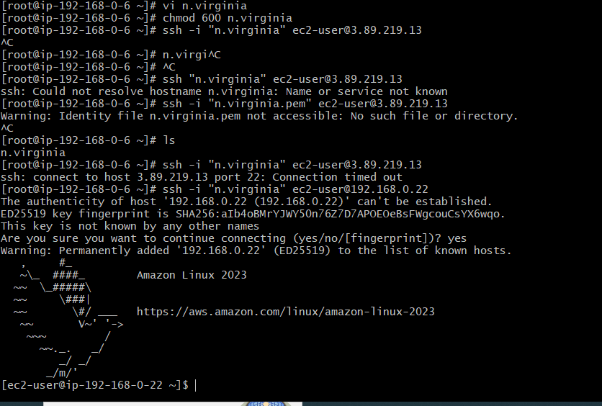

Install apache and start the service
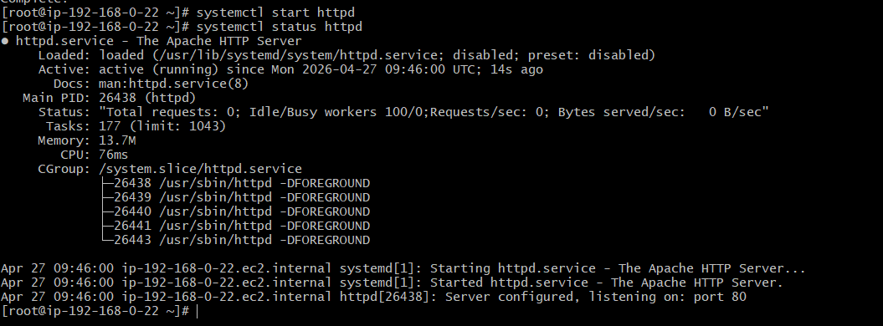
Deploy content in index.html file


- Create one application load balancer and attach it to both EC2 instances.
Create load balancer
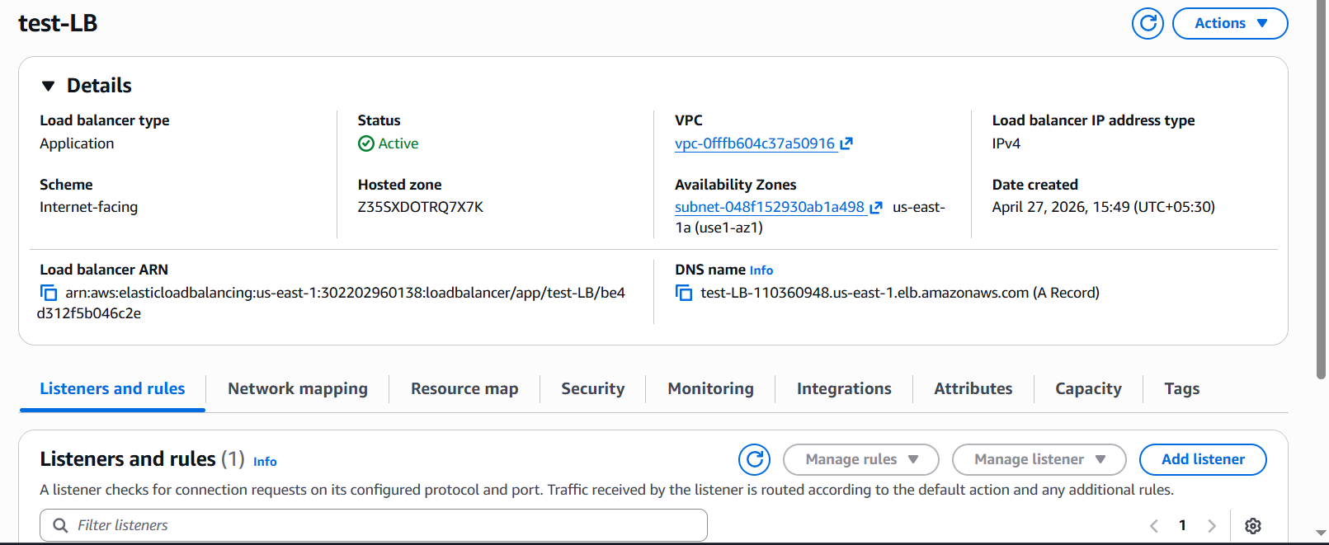

Create a target group for load balancer

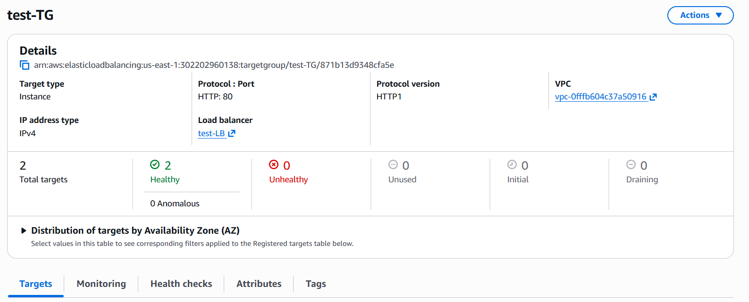

Register targets in target group
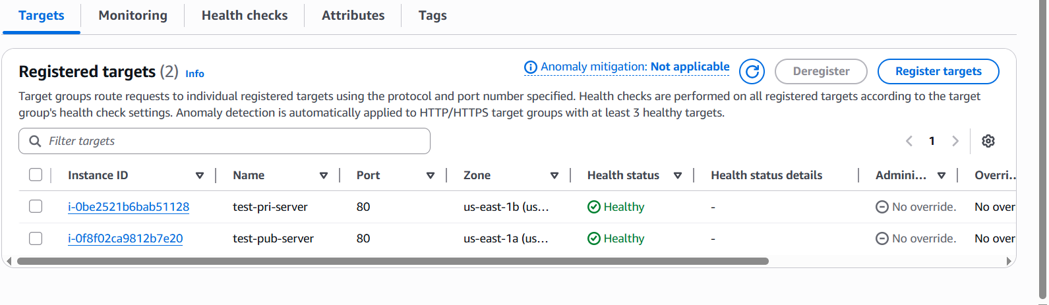

Hit the load balancer DNS in browser check the how load was distribute
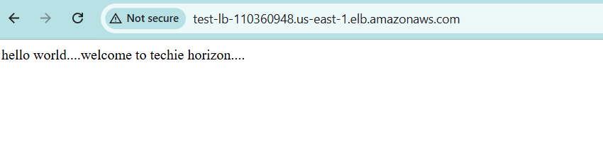

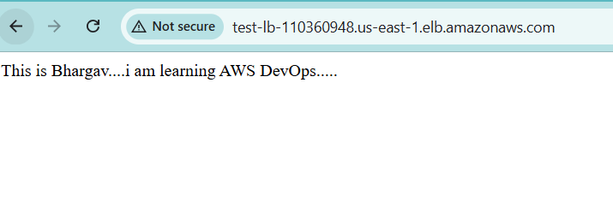

- Store application load balancer logs in S3.

Create s3 bucket for store the load balancer logs
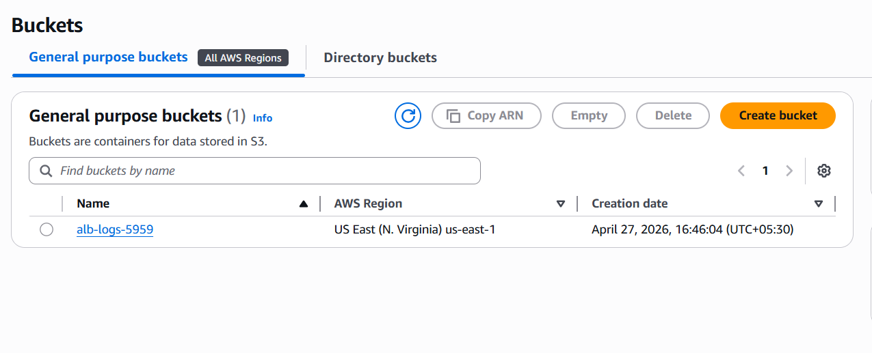
Goto to the load balancer→click attributes→click edit option→monitoring →Enable access logs & connection logs
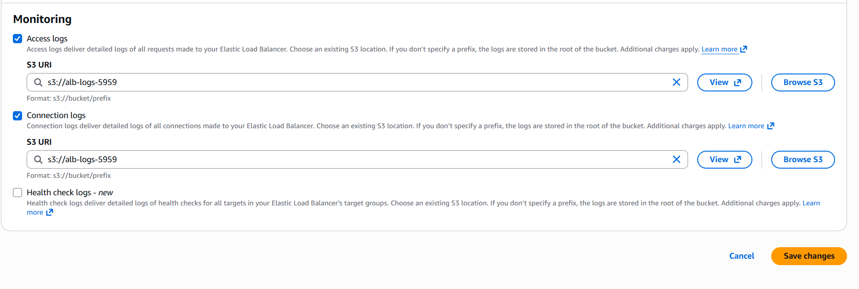

Check the s3 bucket & we can see the logs
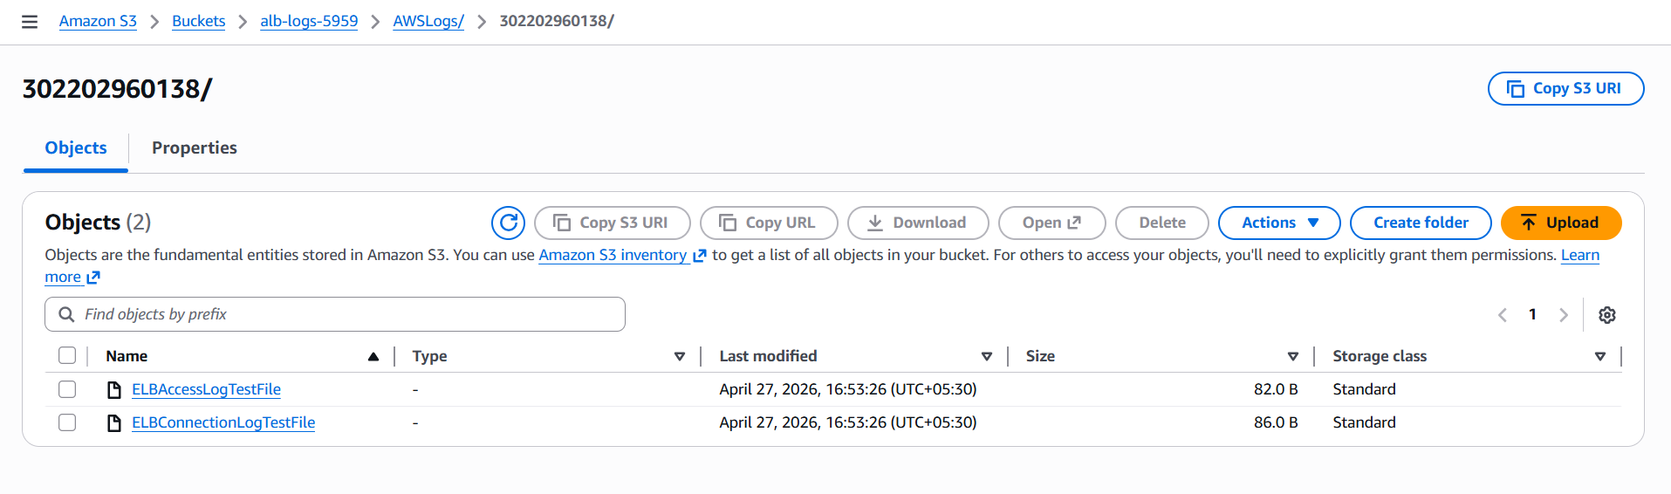

- Store the VPC flow logs in a CloudWatch log group.

Click to vpc →click to vpc flowlogs→with cloudwatch log group→give IAM role for that 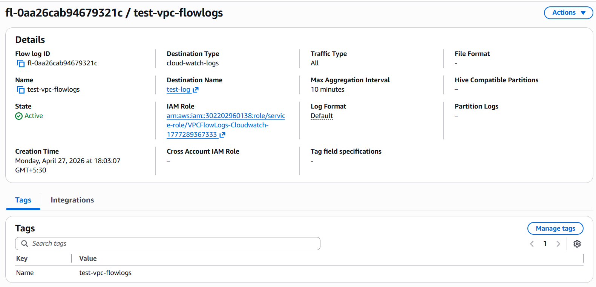

We can see the logs in cloudwatch log group → logstrems
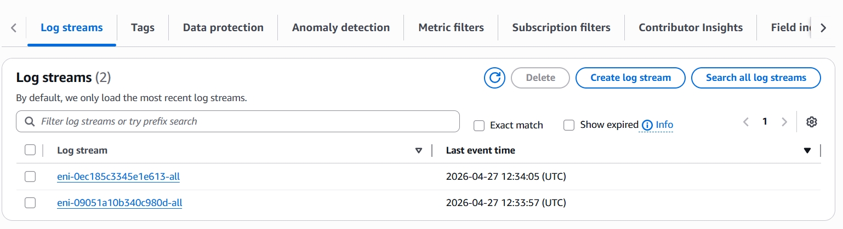

- Create monitoring dashboards to monitor CPU utilization and to monitor the Apache service.

Goto Cloud watch→create dashboard for CPU utilization →add public server & private server
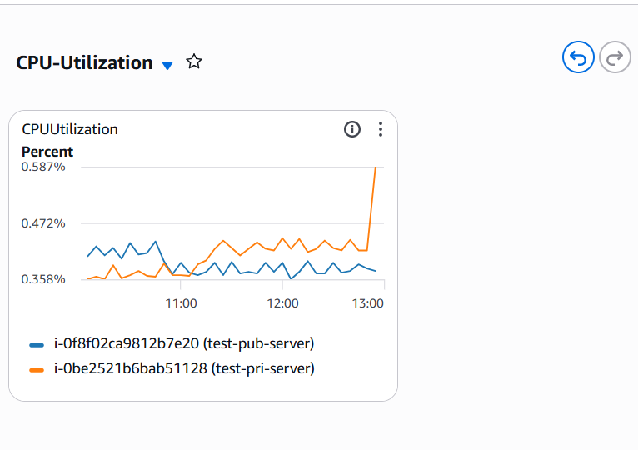

- Create a dashboard for monitor apache service running or not
- Create custom metrics

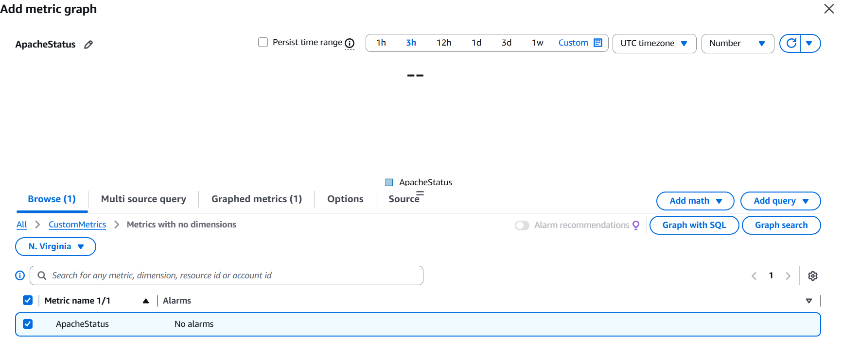

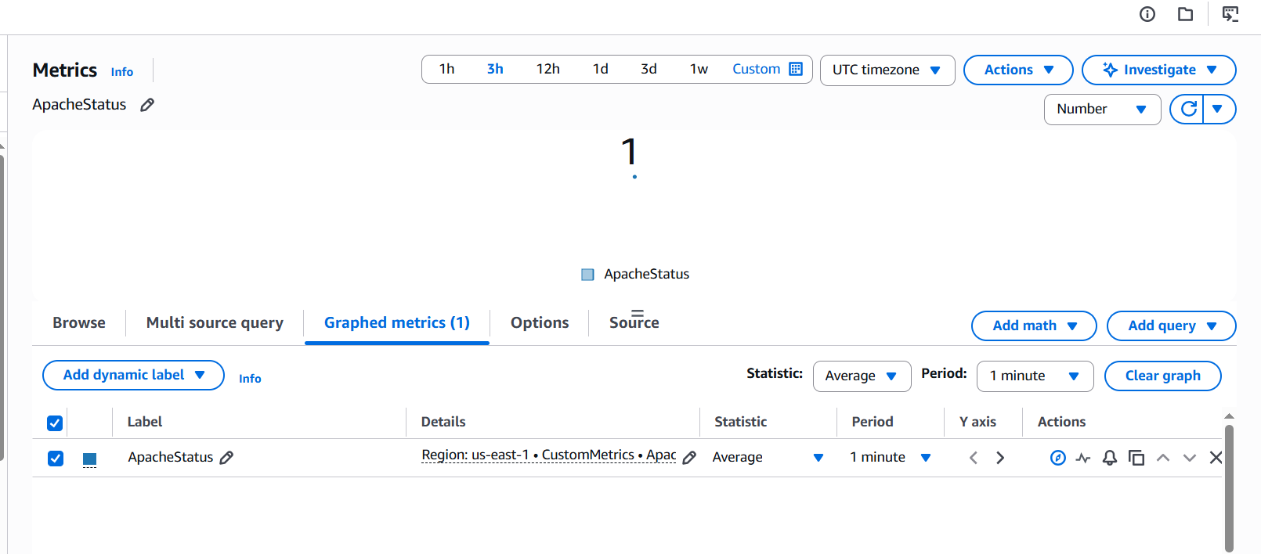

- If CPU utilization is more than 70%, then it should trigger auto scaling and launch new instance
Create AMI for apache server
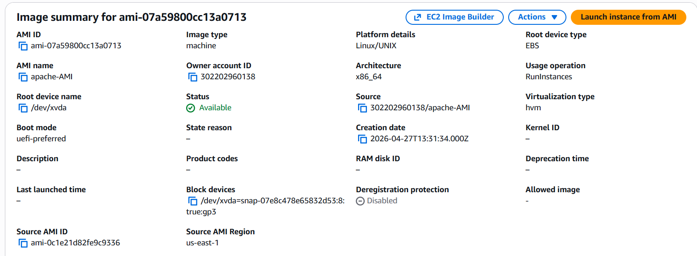

By using AMI we can create launch template
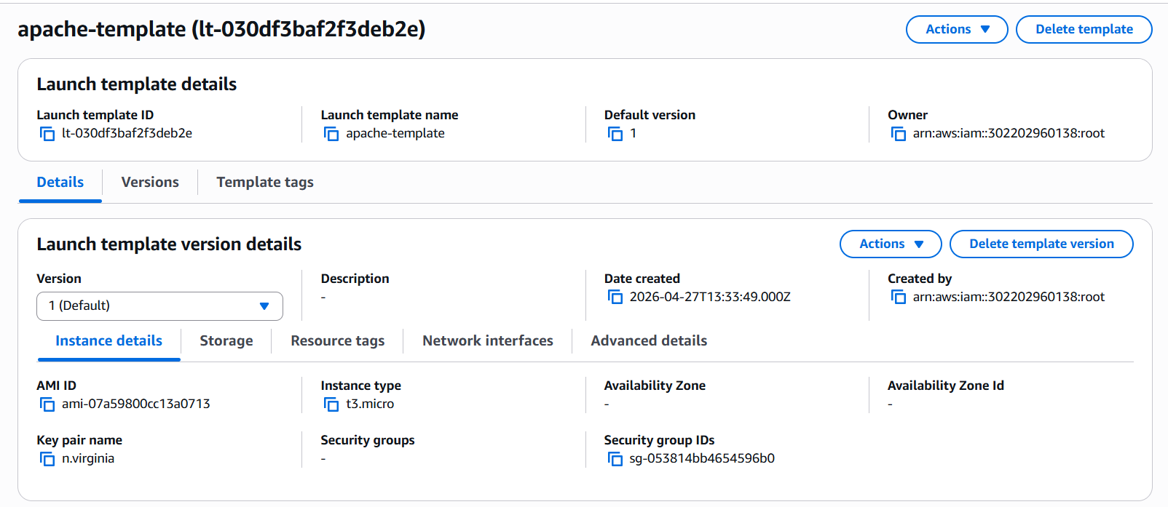

With that launch template we can create auto scaling group
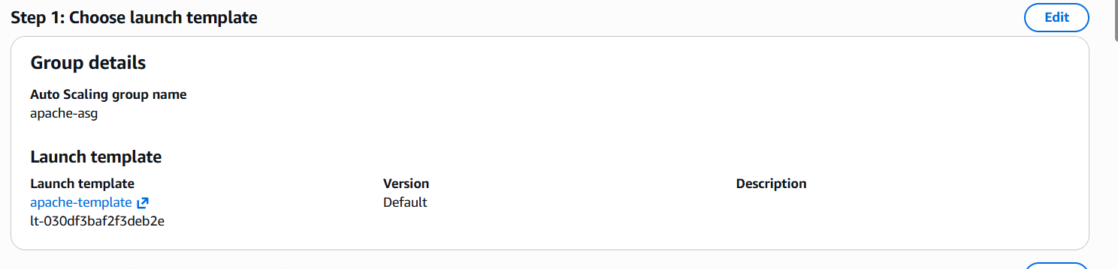
Choose vpc and subnets as well
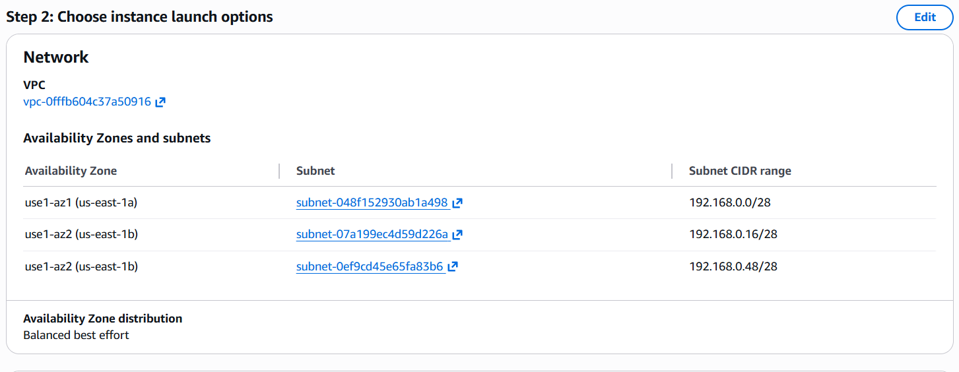

Integrate with load balancer
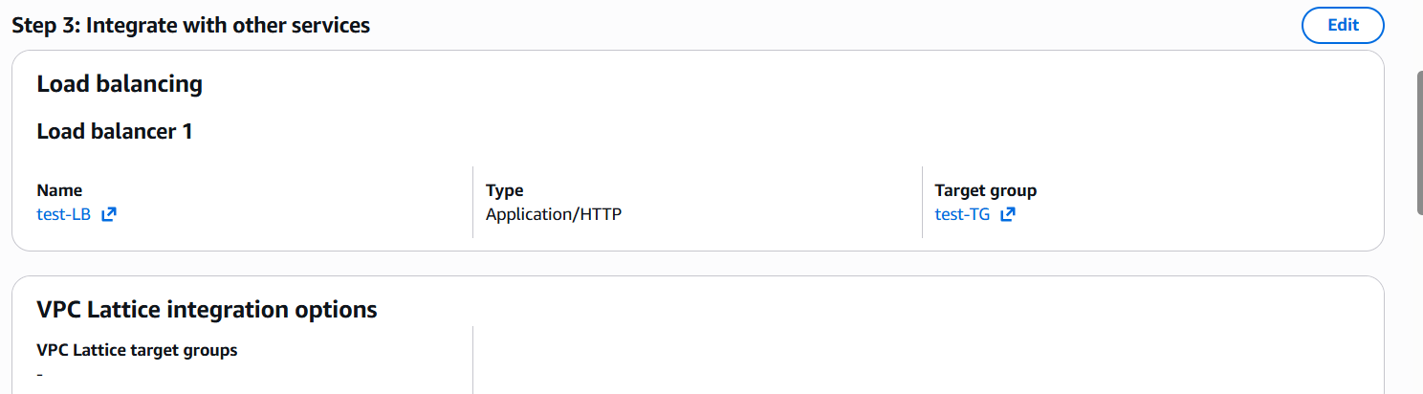

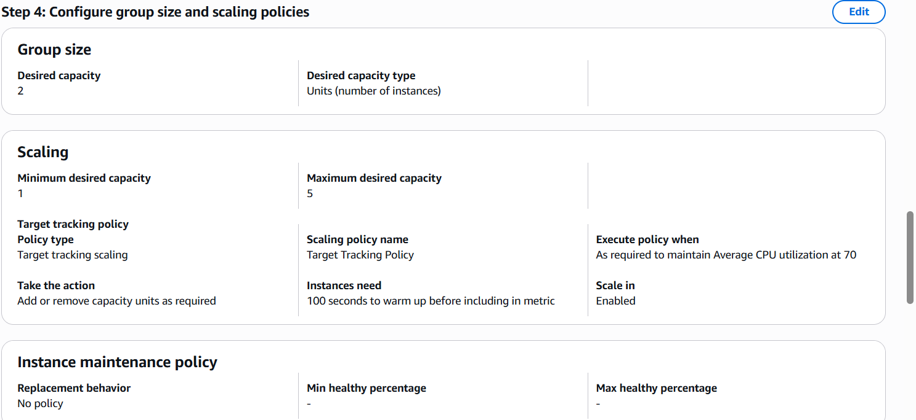

Created auto scaling group
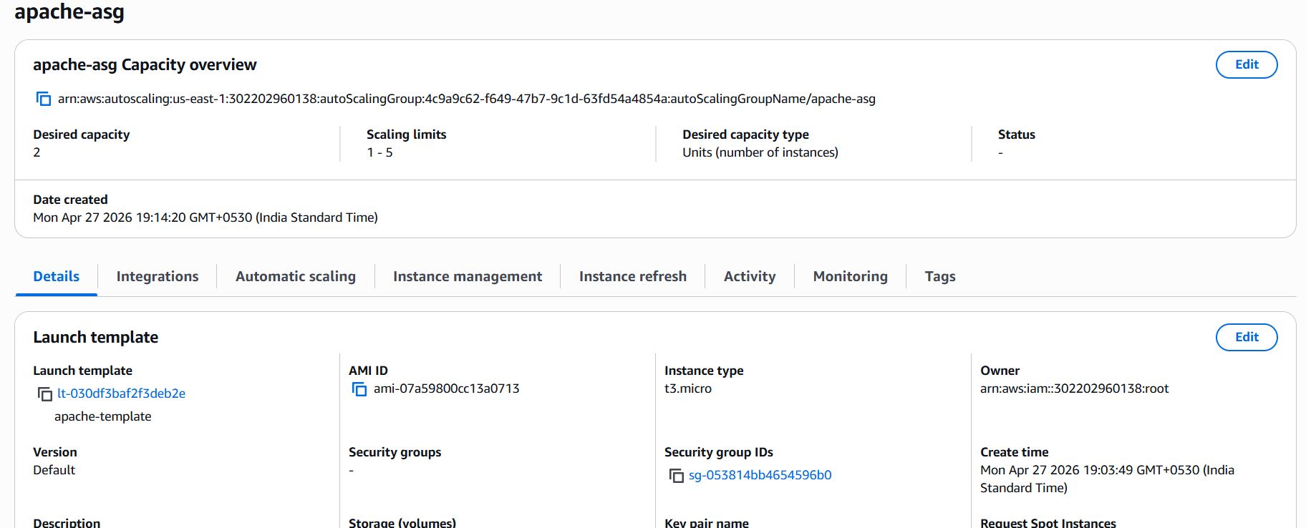
We can check activity tab, what instances created or terminated
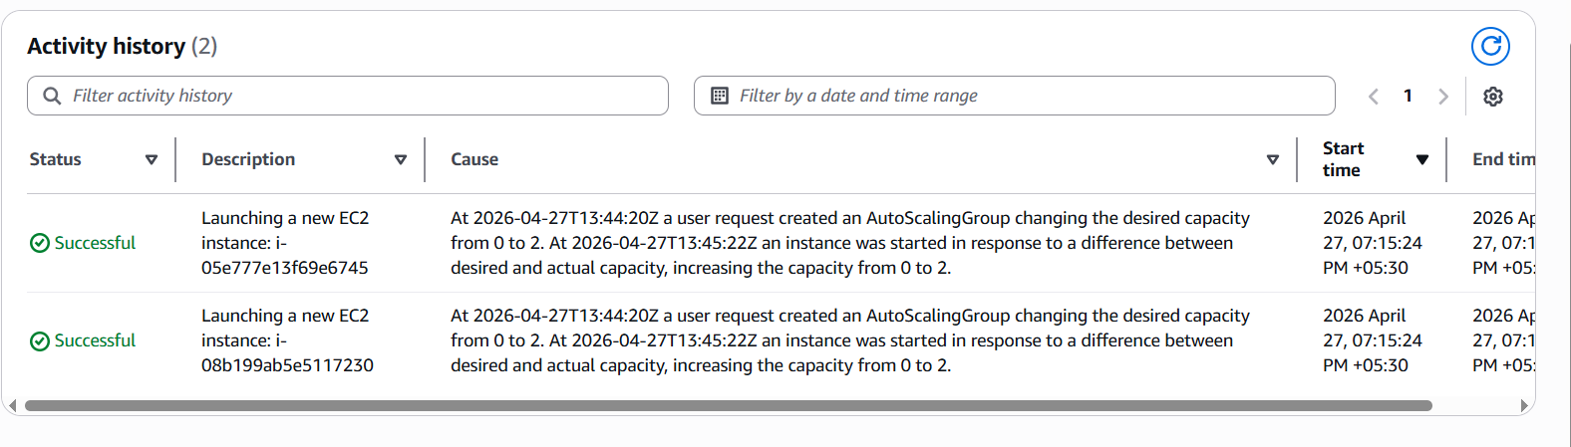

We can automatically create two instances
